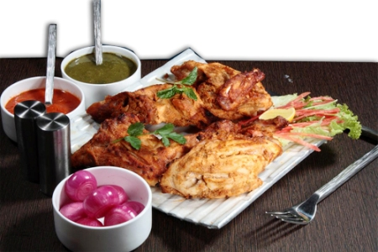

**Afghani Murgh Tandoori**

* 2 small chickens, 750g each
* 1 teaspoon salt
* ½ tablespoon chilli powder
* 2 tablespoons lemon juice
* 500 ml or 2 cups thick plain yoghurt
* 1 tablespoon grated fresh ginger
* ½ tablespoon crushed garlic
* ½ teaspoon cinnamon
* ½ teaspoon black cardamom powder
* ½ teaspoon ground cloves
* Dash of red food colouring
* 3 tablespoons double cream

**Recipe Method:**

1. Halve chickens. Remove skin and make small deep cuts in the flesh. Mix together salt, chilli powder and lemon juice. Rub this mixture over flesh and allow to marinate for 2 hours. Beat yoghurt with ginger, garlic, cinnamon, cardamom and cloves. Mix in red food colouring. Add cream and mix well. Leave chicken in mixture for 1 hour. Thread halved chickens on to skewers and cook in Indian tandoor oven, or over hot charcoal, until chicken is well cooked. Serve hot, garnished with onion rings and lemon wedges.